UNIFIELD – Memo

Load tests

Author: Grégory Bellier
Date: 16.01.2013
Revision: 1
Status: Draft

UNIFIELD – Memo 1
Load tests 1
1 Introduction 2
2 Definition of the testing environment 2
2.1 Synchronization server hardware 2
2.2 JMeter machines 3
2.3 Protocol 3
2.4 Synchronization server monitoring 3
3 Tests environments 3
3.1 Laboratory 3
3.2 Degraded network 4
4 Test sizing 4
4.1 Sizing 4
5 Tests scenarios and validation criteria 4
5.1 Differences between the first campaign and the second 5
5.2 Mass update of master data 5
5.3 Regular / day to day processes 6
5.4 Monthly process 6
6 Results 7
6.1 Best conditions 7
6.2 Degraded conditions 7
6.2.1 Impact of the latency 7
6.2.2 Impact of the bandwidth 7
6.2.3 Impact of the packet loss 7
6.2.4 Impact of the number of instances 8

Introduction
The main goal of the load tests is to determine if the architecture of the synchronization server is robust enough to handle the load induced by the instances in real conditions.
Neither the instances nor functional tests are the goal of these tests.
The first test campaign was globally a success with the exception of TS_2, pulling data was taking too much time. With degraded conditions, the tests were executed correctly with durations multiplied by 4 to 24.
This second campaign helps to discover the impact of the improvements and if there is any regression. Some of the first campaign tests scenarios cannot be the same than this one, because of development changes between the 2 versions.
The first campaign was performed on version dsp4synchrc2.
The second campaign is performed on version pilot 0.4.

Definition of the testing environment
As we won’t be able to test with hundreds of installations, the only way is to generate volumes and measure the performance using dedicated tools such as JMeter. JMeter will act as a replacement of local instances on field.
There is only one synchronization server.

Synchronization server hardware
The server configuration is the same than for the first campaign:
- Dell PowerEdge R620
- Memory: 64 GB, (8 × 8 GB) at 1333Mhz
- CPU: Intel Xeon E5-2643, 4 × 3.3 Ghz, 10MB cache
- 4 Hard drives and 1 hardware-raid card (PERC H310):
  - Raid-0: 2 HDDs (300 GB, SAS, 15k rpm) => system (/ formatted in ext4)
  - Raid-0: 2 HDDs (300 GB, SAS, 15k rpm) => PostgreSQL databases (/var formatted in ext4)
- Broadcom NetXtreme BCM 5720 Gigabits Ethernet 4 ports (only one will be used)
- OS: Ubuntu Server 10.04 LTS 64 Bits

JMeter machines
5 physical machines simulate the behaviour of local instance servers driven by a master node which is a 6th physical machine. Those machines are lent by OCG and are standard ones:
- 4 × HP Compaq 8200 Elite Ultra-Slim desktop
- 2 × Lenovo Thinkpad T420

Protocol
XML-RPC is the greediest protocol, that’s why it was chosen.

Synchronization server monitoring
Although OpenERP provides some basic monitoring informations regarding the application, it cannot monitor the system as it is a completely different scope.
The monitoring will be performed by Munin.

Tests environments

Laboratory
In laboratory conditions, the network must have the best conditions (highest bandwidth, almost none packet loss, lowest latency) to induce the highest workload on the server.

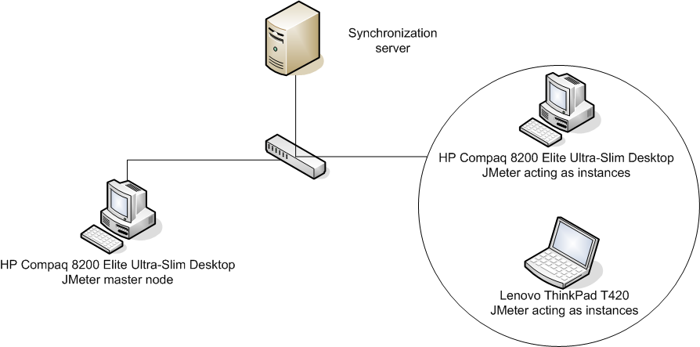
Fig 1. Best possible network conditions

Degraded network
The objectives of these tests are to be close to the conditions on field. Some tests vary the latency, the bandwidth, the packet loss, the number of projects or a combination of these.

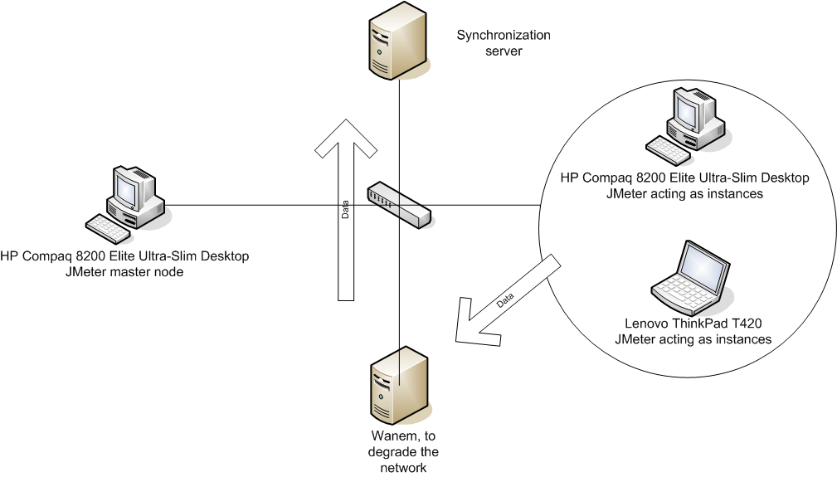
Fig 2. Degraded conditions with Wanem

Test sizing
All tests are performed in the two environments described in the previous paragraph.

Sizing
The tests will be conducted with:
- 5 OCs
- 105 coordinations
- 270 projects
registered into the database.

The max_size will be set to 500. It means that each packet can contain up to 500 elements (for example: products) as long as the same rule applies to all.

Tests scenarios and validation criteria
Every single test implies the whole synchronization (pull data, pull message, push data, push message)

Differences between the first campaign and the second
- The first campaign was performed on the version dsp4synchrc2 while the second one is on pilot 0.4, a version very close to pilot 1.0
- Since the first campaign, some tests needed to be adapted due to recent developments. What used to be TS_7, TS_8 and TS_9 is now TS_9bis. The original Test Scenario numbers were kept so that the comparison with the results of the first campaign is made easier.

Mass update of master data
- TS_1: Sending updates of the ITC item database from the OC instances to the synchronization server
  - Conditions:
    - 7000 updates / OC
    - 5 OCs simultaneously

- TS_2: Sending updates of the ITC item database from the synchronization server to the coordination instances
  - Conditions:
    - Each instance pulls the items sent by its OC at TS_1
    - 40 coordination instances simultaneously
  - Validation criteria:
    - Time of execution: < 1 hour

- TS_3: Sending of FX rates from the OC instances to the synchronization server
  - Conditions:
    - 158 currencies / OC
    - 5 OCs simultaneously
  - Validation criteria:
    - Time of execution: < 5 minutes

- TS_4: Sending of monthly FX rates from the synchronization server to the coordination instances
  - Conditions:
    - Each instance pulls the FX rates sent by its OC at TS_3
    - 40 coordination instances simultaneously
  - Validation criteria:
    - Time of execution: < 5 minutes

Regular / day to day processes
- TS_5: Sending of POs creations from the project instances to the synchronization server
  - Conditions:
    - 4 POs / OC
    - 60 project instances simultaneously
  - Validation criteria:
    - Time of execution: < 5 minutes

- TS_6: Sending of FOs creations from the synchronization server to the coordination instances
  - Conditions:
    - Coordination instances pull respectively the PO created at TS_5 by the Project instances
    - 20 coordination instances simultaneously
  - Validation criteria:
    - Time of execution: < 5 minutes

- TS_9bis: Sending of registers lines from the coordination instances to the synchronization server
  - Conditions:
    - 22 register lines / instance
    - 40 coordination instances simultaneously
  - Validation criteria:
    - Time of execution: < 5 minutes

Monthly process
- TS_10: Sending of newly created registers from the project instances to the synchronization server
  - Conditions:
    - 6 registers / instance
    - 60 project instances simultaneously
  - Validation criteria:
    - Time of execution: < 5 minutes

- TS_11: Sending of newly created registers from the synchronization server to the coordination instances
  - Conditions:
    - Coordination instances pull the newly created registers at TS_10
    - 20 coordination instances simultaneously
  - Validation criteria:
    - Time of execution: < 5 minutes

Results

Best conditions
Scenarii | Time taken
TS_1
TS_2
TS_3
TS_4
TS_5
TS_6
TS_10
TS_11
TS_9bis

Degraded conditions

Impact of the latency
100 Kbit, 1.5% Packet loss, 40 projects, 5 injectors degraded
 | 100 ms | 700 ms | 1300 ms
TS_1 1000 products
TS_5
TS_9bis

Impact of the bandwidth
700 ms, 1.5% Packet loss, 40 projects, 5 injectors degraded
 | 32 Kbits | 64 Kbits | 128 Kbits
TS_1 1000 products
TS_5
TS_9bis

Impact of the packet loss
700 ms, 100 Kbits, 40 projects, 5 injectors degraded
 | 0 % | 2 % | 4 %
TS_1 1000 products
TS_5
TS_9bis

Impact of the number of instances
700 ms, 100 Kbits, 1.5% packet loss, 5 injectors degraded
 | 100 projects | 200 projects | 300 projects
TS_1 1000 products
TS_5
TS_9bis
TS_12

Note: TS_12 is TS_5 + TS_9bis

